Hunter Sutton

Chuck A Luck Project 2

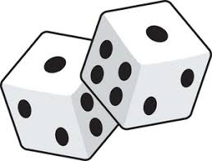

"I pledge that this work is entirely mine, and mine alone (except for any code provided by my instructor). "

I had no help from anyone besides the professor.

Timecard

“I spent 10 hours on this project from November 1st – November 17th reading the zyBooks, writing code, fixing errors and putting together my final document.”

**Sample Output:**

This is what was in my Chuck Test.

**------------------------------**

Getting Credits

10

Rolling

Dice to string

[1,6,2,]

Getting message

You Lost!

Testing begins...

Testing completed.

**Screenshot of Chuck A Luck JUnit Test showing what I passed.**

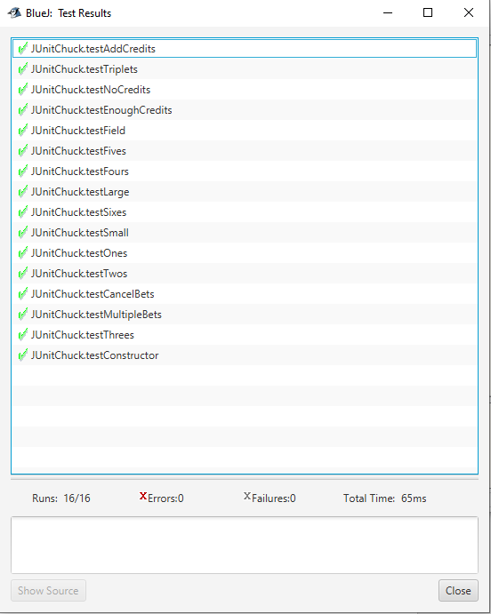

**Screenshots of The GUI working.**

